
Digital Pirani Vacuum Gauge- HPRGE-1GH-SP
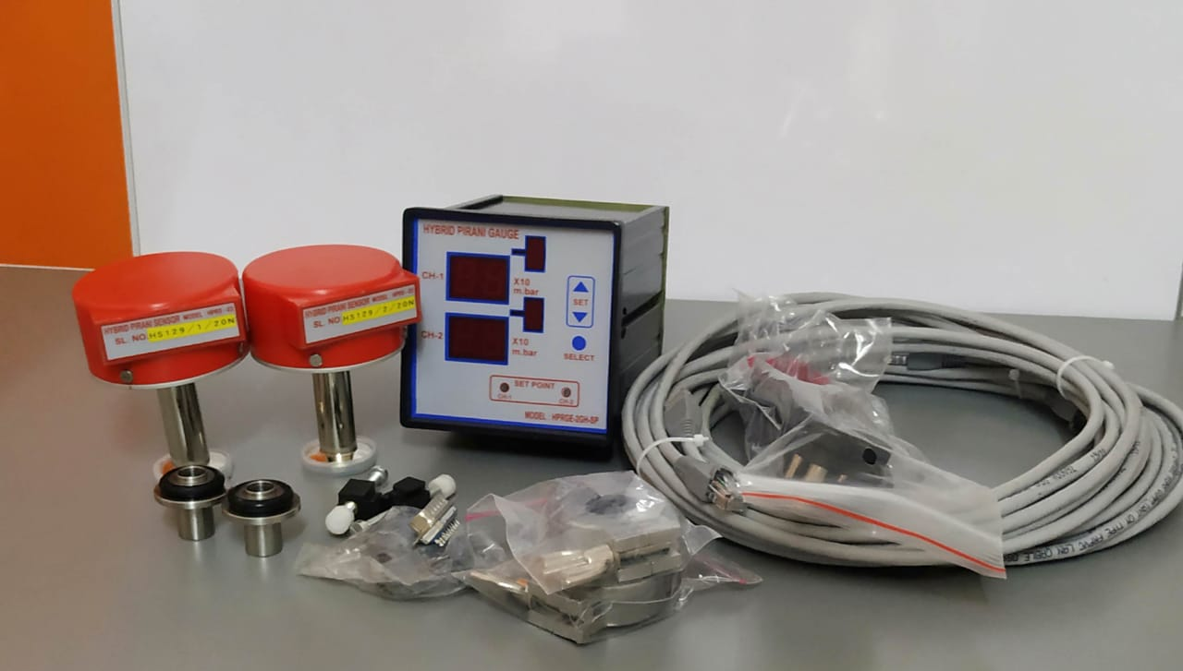
Accuracy @ 25 °C
From 1000 to 1 mbar | +/- 2.5%
From 1 mbar to 0.001 | +/- 15%
(Illustrated image is with dual channel input)
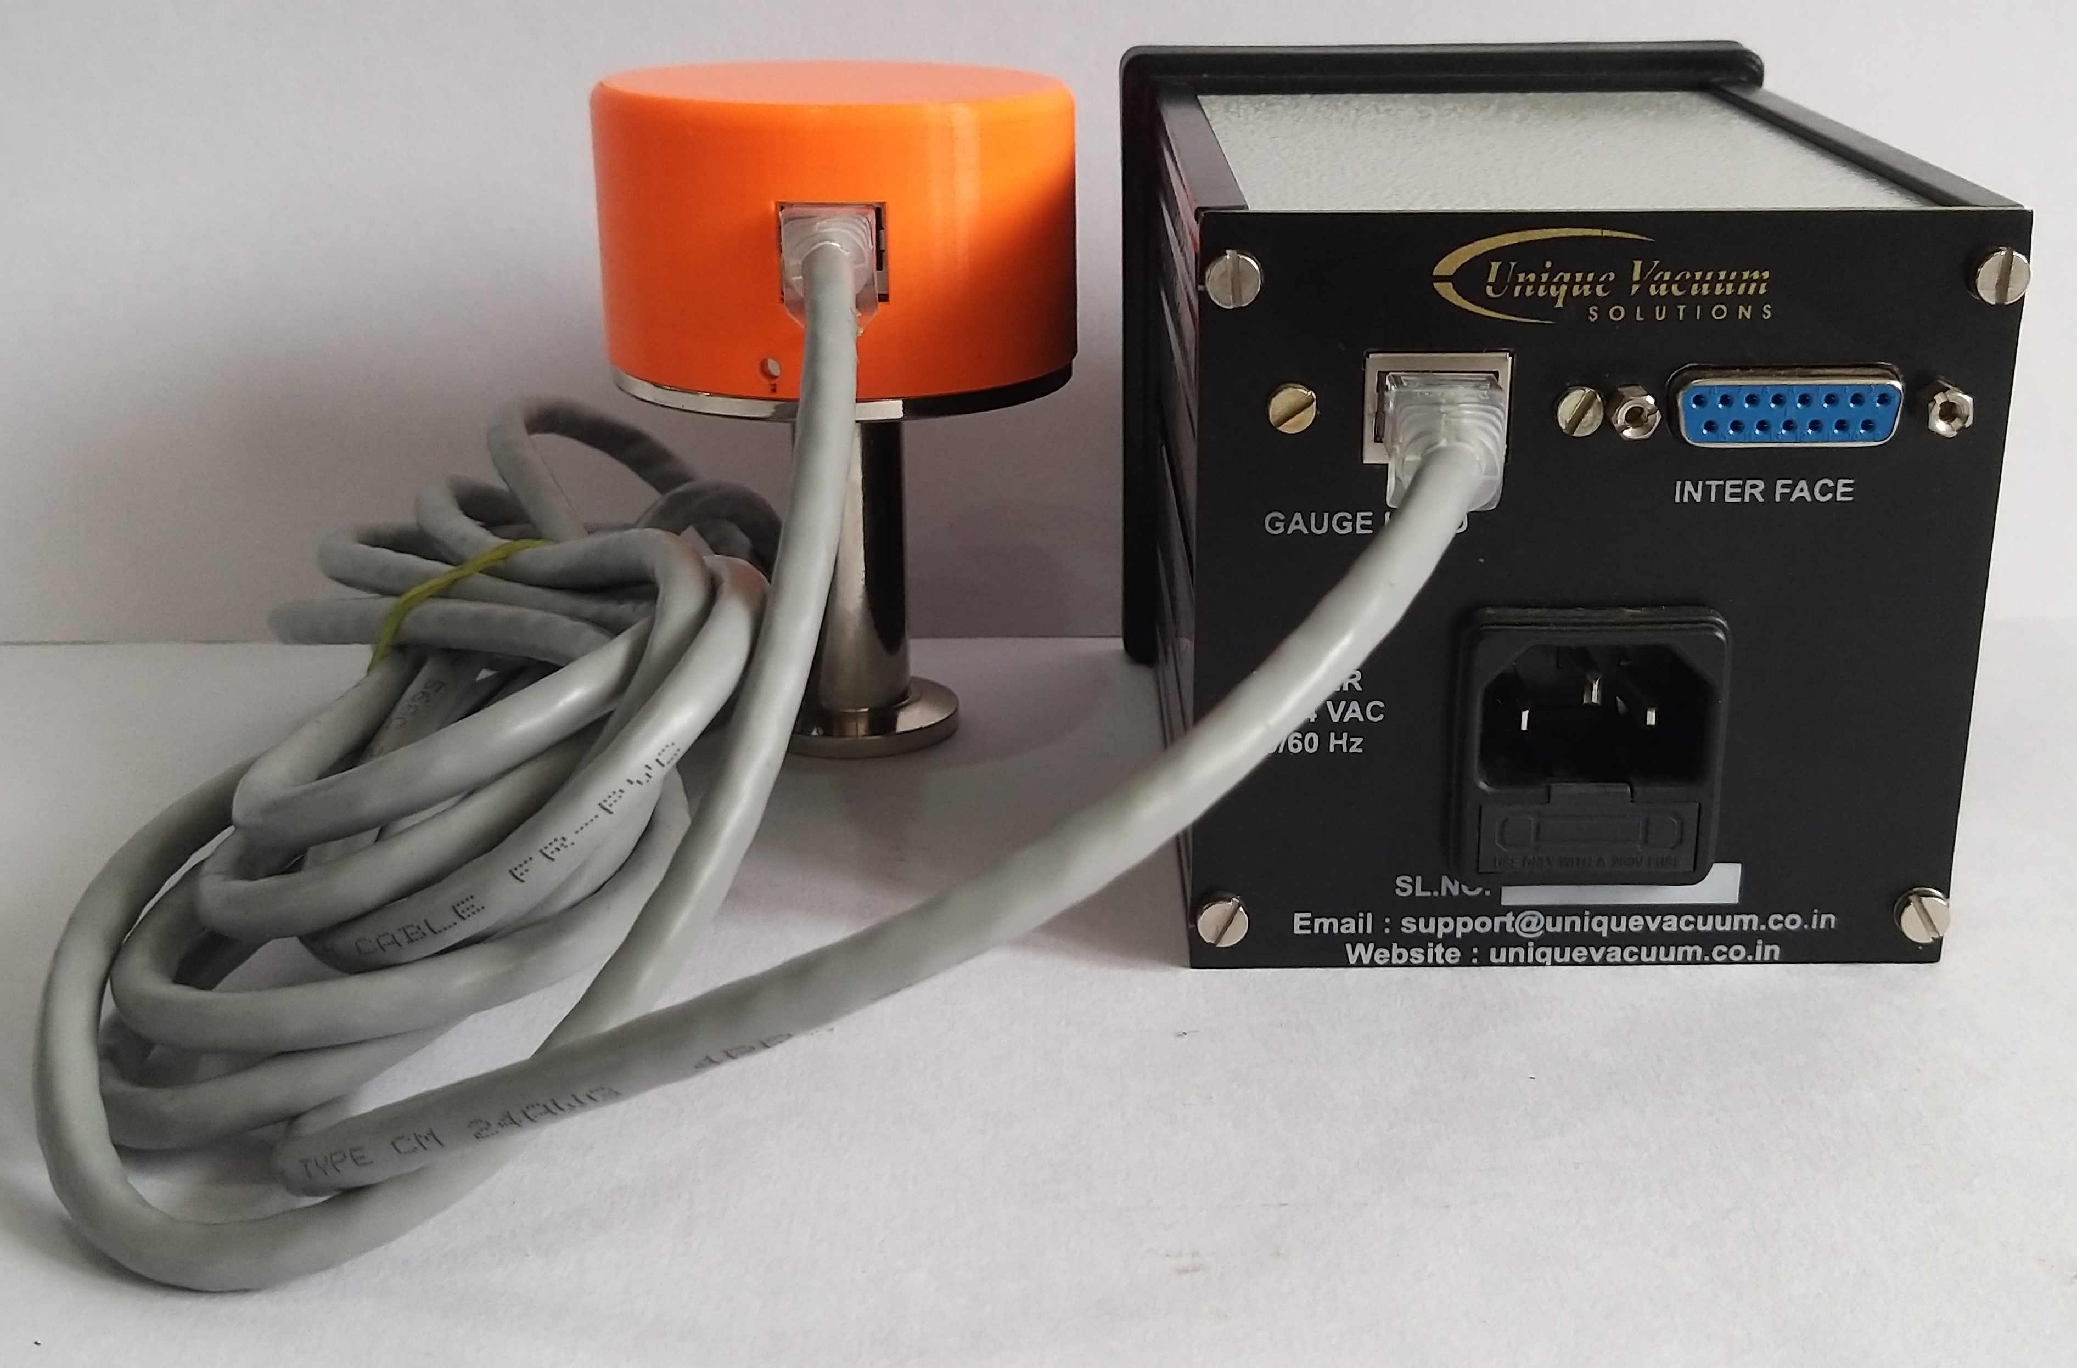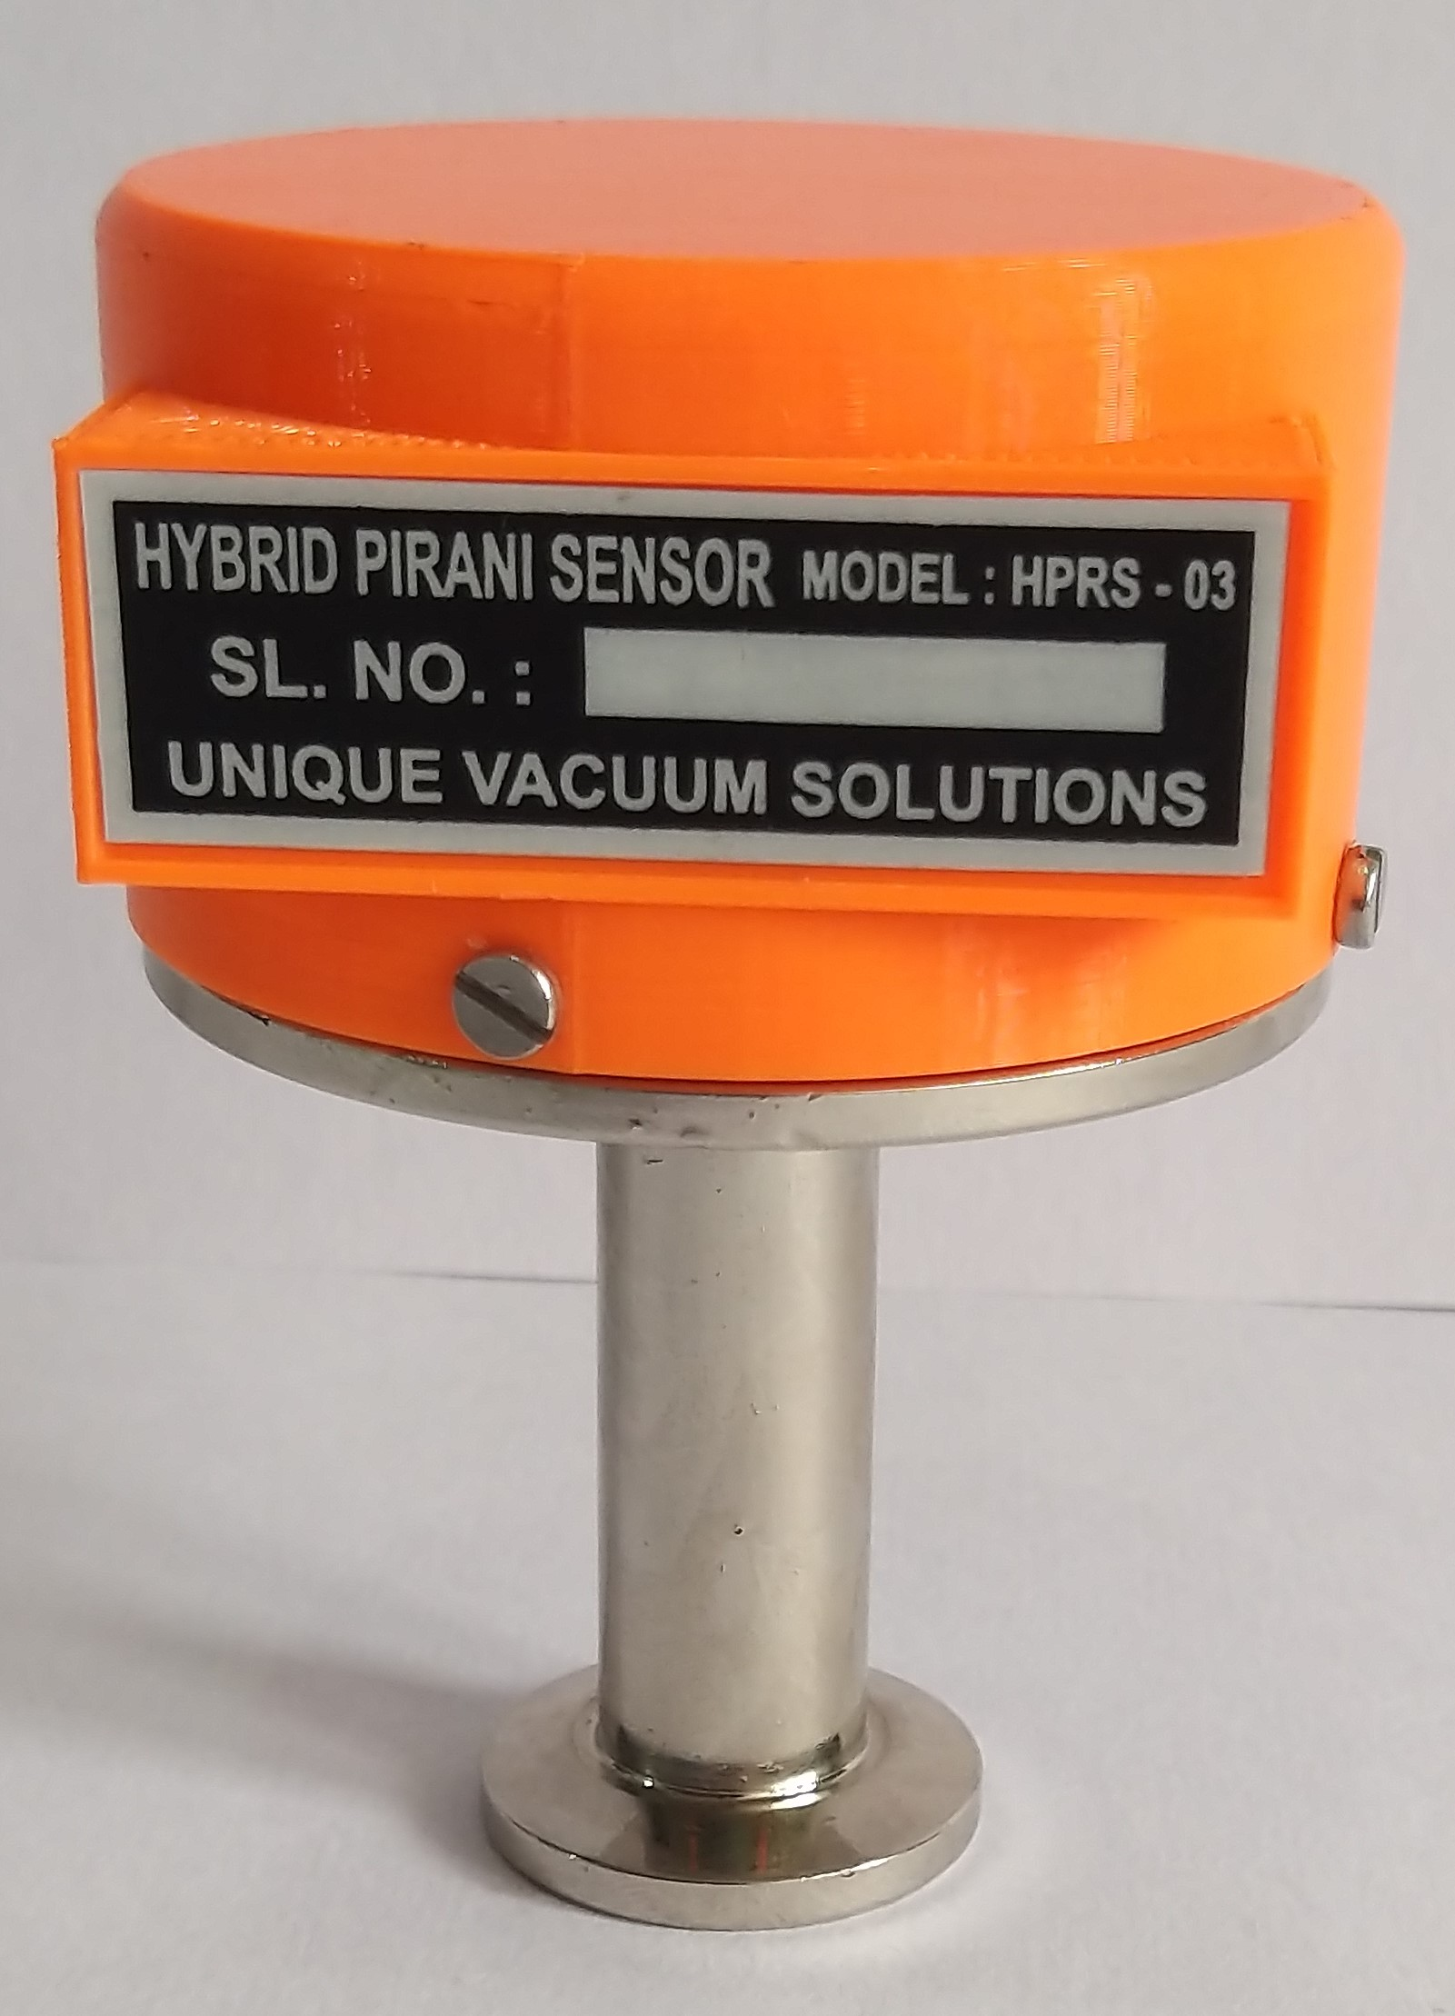
Special Features:
- specially designed for large volume evacuation vacuum readouts.
- High Accuracy At Higher Pressures from 1000 mbar to 1 mbar
- Very useful for accurate measurement of vacuum from 1000 mbar to 1X10e-4 mbar
- Brass body measurement sensor with standard KF-10 / KF-16 optional KF-25 end fitting.
TECHNICAL SPECFICATIONS - Sensor
MODEL | S-EPR-GH
On board sensor Display range | 1000 mbar to 1X10e-4 mbar
Display type ( on sensor) | Exponential format display x.ye-z)
Units of measurement | Mbar
Temp range | +2 to 50 deg C
End connection | Standard NW10 (optional NW16/25 available)
Output | 4 to 20 mA
Digital interfacing | RS485 ( standard RTU modbus protocol)
Zero & span adjustment | Through Push button (at sensor end)
Operating voltage | +15V,0, -15V DC
Mounting orientation | Vertical only
Environmental conditions for operation | Not recommended for high moisture levels & corrosive gases evacuation

TECHNICAL SPECFICATIONS – Display Controller
MODEL | HPRG-1GH-SP
Number of sensor channels | One
Display range | 1000 mbar to 1X10e-4 mbar
Display type | 7 segment Exponential order display display (x.ye-z)
Units of measurement | Mbar
Vacuum gauge head compatible. | S-EPR-GH
Temp range | +2 to 50 deg C
Zero and full scale adjustment | At sensor END
Process control relay set point output | One  Potential free NC-COM-CO contacts
Non-volatile memory | Only for setpoints
Input signal | RS485 modbus output from sensor S-EPR-GH
Operating voltage | From 96 to 264 v AC / 50 Hz
Overall dimension | 92W X 92H X 110D mm
Input supply voltage | 220V, 50 Hz

UNIQUE VACUUM SOLUTIONS
#57, 8th cross, 1st B cross, Doddanna Industrial Estate, Vishwaneedam post, near Peenya 2nd stage, Bangalore-560091. PH: +91-9886726920, 080-28367059
nagendrautpath@uniquevacuum.co.in, support@uniquevacuum.co.in, support@heliumleaktesting.net.in
www.uniquevacuum.co.in, www.heliumleaktesting.net.in
Helium Leak testing -- Helium Leak test Systems -- Vacuum Measuring Gauges
Vacuum Gauges & Std leak Calibration Services -- High Vacuum Systems

